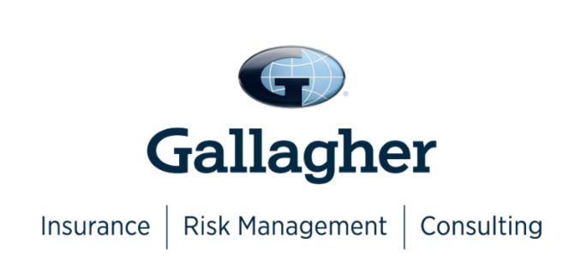

Join Your SAHRMA Peers by Participating in Gallagher’s Annual Benefits Survey

Prepare to better attract and retain a competitive workforce by completing Gallagher’s 2022 Benefits Strategy & Benchmarking Survey.

Confidently face your future with informed strategies and decisions based on data. By participating in this research, your entire organization gains complimentary access to Gallagher’s 2022 Workforce Trends Report Series as outlined below. There will be a total of seven reports published in 2022 based on the results of this one survey.

- People & Organizational Wellbeing Strategy
- Physical & Emotional Wellbeing
- Career Wellbeing
- Financial Wellbeing
- Organizational Wellbeing
- Best-in-Class Benchmarking Analysis
- State of the Sector: Internal Communications & Employee Experience

You can preview the 2021 Workforce Trends Report Series data by reviewing the Report. 2022 survey participants will have complimentary access to the full set of 2022 reports.

If 25 or more different organizations who are SAHRMA members participate in the survey, Gallagher will be able to provide SAHRMA members with local benchmark data based on the results. This is in addition to the national data that will be provided.
Click here to register for your unique survey link: www.ajg.com/2022NBS-SAHRMA

